Static Culling Transparency

StaticCulling automatically knows how to detect transparent objects and select the right settings. But it is important to know how to do it yourself.
The objects in this scene were baked incorrectly, so the blue cube is not visible behind the transparent barrier.

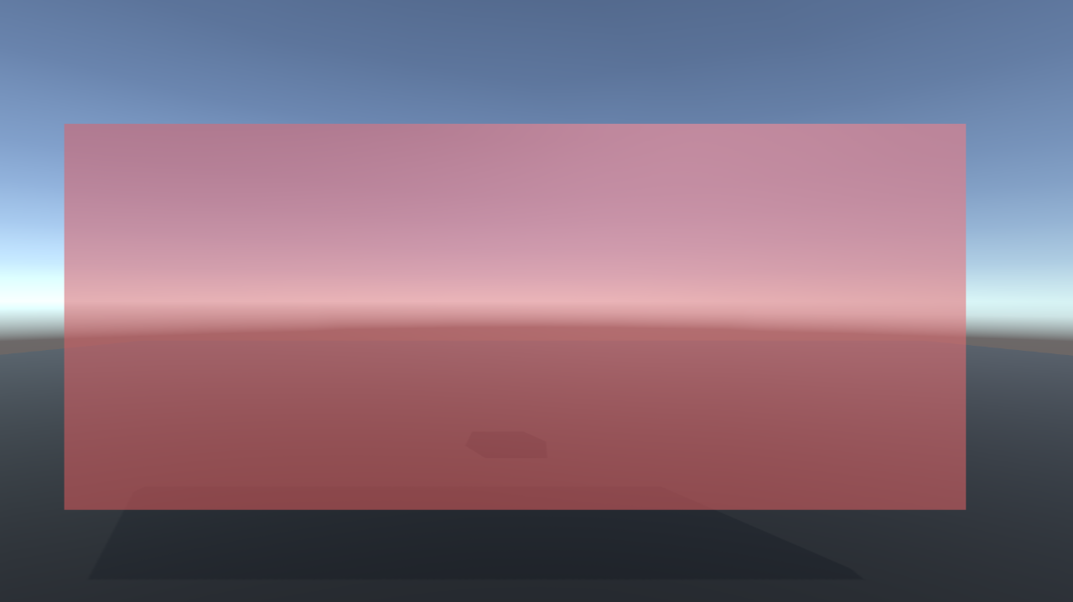

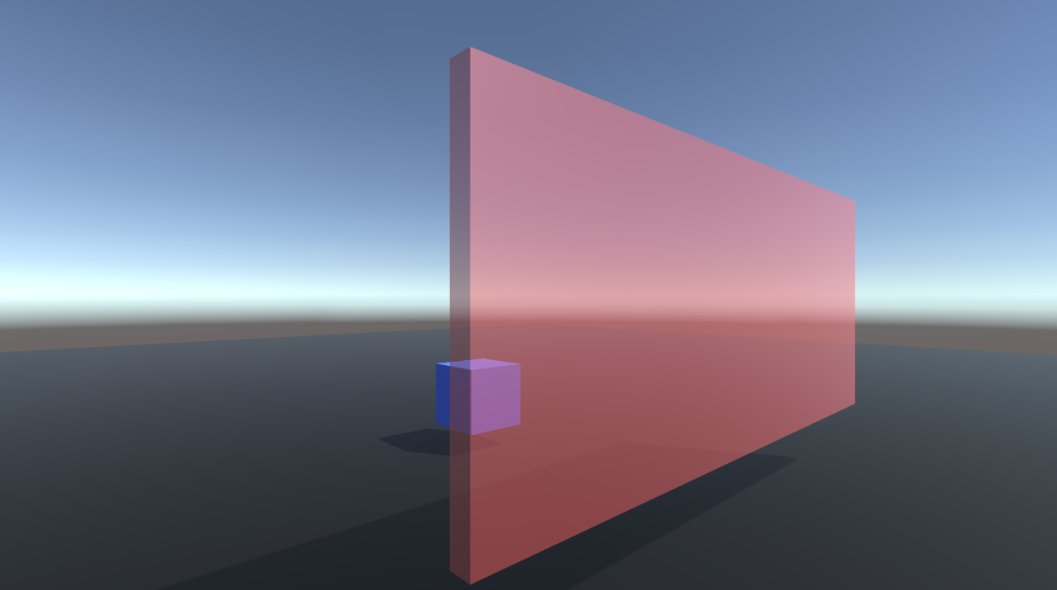

- To fix this - let's start by deleting the baked data. Click “Clear” button in StaticCullingController
- Add objects using the Selection Tool.
- Add an existing CameraZone in Step3
- Click on the Barrier GameObject and make sure the isOccluder flag is off. For all transparent objects, this flag should be turned off.

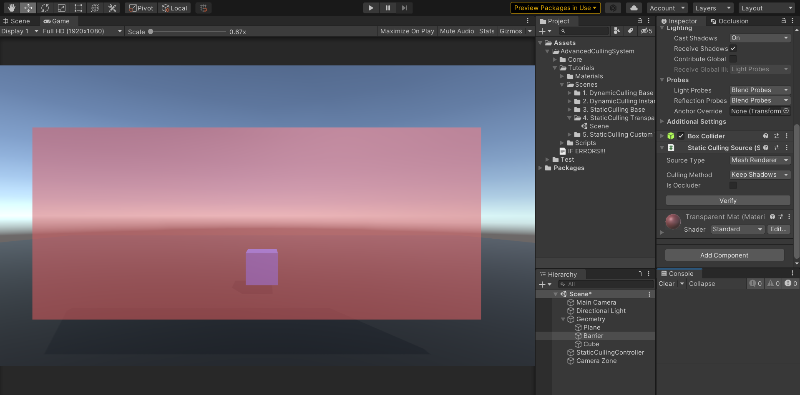

- Now bake the scene and look at the result.

